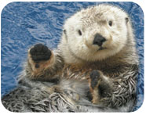
Introduction
The Sea otter (Enhydra lutris) is the smallest marine mammal in North America, and occupies the chilly coastal seas of the central and northern Pacific Ocean. Sea otters average around 1.2 meters in length, and typically weigh 25 kilograms (Environment Canada, 2011). The otters rely on their dense and soft fur coats for warmth, allowing them to survive frigid temperatures. Their fur consists of an outer layer of guard hairs, which are extremely fine and dense (100,000/cm²). Oils from the skin glands also help to increase the water repellency of the fur (Environment Canada, 2011). For the sea otter, it is important to keep their hair clean, otherwise it could become matted, which would reduce its effectiveness and possibly lead to hypothermia. During grooming, the hairs are cleaned and aligned, and oil is blown through the fur and is captured in tiny water repellant bubbles (Environment Canada, 2011).
There are 12 species of otters worldwide, and all have streamline bodies and live exclusively in aquatic environments. They possess a variety of adaptations which include hind flippers for locomotion, flattened premolars for crushing hard shelled organisms, and large kidneys to process large amounts of ingested sea salt (Fisheries and Oceans Canada, 2014). Sea otter pups are identified by light brown or yellowish fur, which will be replaced within a few months of life.
The sea otter has little to no body fat, meaning that to survive in the chilly aquatic environment, they must rely on their thick fur and maintain an extremely high metabolic rate. This rate is 2.4 to 3.2 times higher than that of terrestrial mammals of approximately the same size (Environment Canada, 2011). To continue this internal heat production, the sea otter must consume 22%-33% of their body weight every day (about 8 kilograms).
The sea otter will mainly eat shellfish and sea urchins, but can also adapt to whatever food is easily available. The sea otter can dive to depths of up to 36 meters and for as long as up to one minute to find food. They therefore must inhabit relatively shallow waters to maintain this lifestyle. To eat their food, otters will usually roll onto their backs and place their meals on their stomachs. They may use rocks to help crack open the shells of sea urchins or other prey (Fisheries and Oceans Canada, 2014).
The sea otters used to be abundant along virtually the entire west coast; however the maritime fur trade in the 18th and 19th centuries changed all that. The otters were hunted for their pelts, and a total of around 55,000 otter pelts were taken from North America. By 1850, sea otters in Canada were considered commercially extinct. However, 89 sea otters were reintroduced to the coast of BC from 1969-1972. This effort was considered successful, as the population grew, and sea otters are once again part of the ecosystem. After being considered extirpated, the sea otter went from an endanger animal, to threatened, and as of 2004, they were upgraded to of special concern. Now, although sea otters are no longer an endangered species, they still are of special concern because of their susceptibility to oil spills and the catastrophic effects that an oil spill would have on the population (Fisheries and Oceans Canada, 2014).
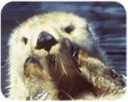
Characteristic of Populations
Primary Population Characteristics
The sea otter was once found throughout the coastal regions of the Northern Pacific Ocean. At one time, the populations spanned continuously from northern Japan to central California, however the near extinction as a result of the fur trade caused the population to diminish. As a result, sea otters were only located in small populations in California, Alaska and Russia. Now, they occupy about half of their original range, and continue to expand (Bodkin, 2012).
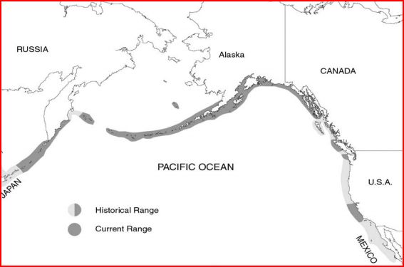
Within Canada, sea otters were originally reintroduced to Checleset Bay. Until 1987, otters occupied only Nootka Island and Checleset Bay off of Vancouver Island. By 1992, the otter population had increased, and continuously spanned Vancouver Island, from Estevan Point to Quatsino Sound. Finally, by 2004, sea otters in B.C were found throughout the Vancouver Island coast, and even north of Milbanke Sound (Bodkin, 2012) as shown in figure 2.

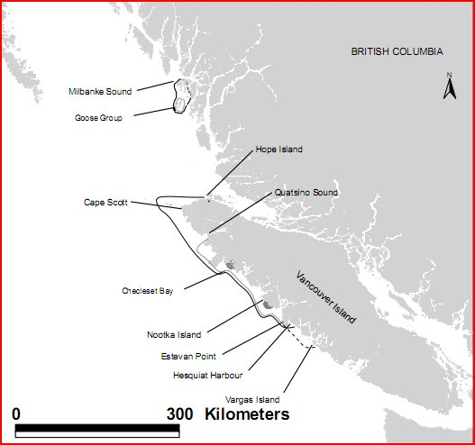
Consistent with most mammals, sea otters exhibit the clumped dispersion pattern (Bodkin, 2012). Sea otters will occupy the coastal waters of the Northern Pacific Ocean. They tend to live around 1-2 kilometers from shore, because of the optimal depth required when diving for food. In fact, sea otters will sometimes rest in groups called “rafts,” and hold hands to stay together. The females and their pups will stay on the inside of the raft, while the males stay to the outside.
Sea otters are density dependent, because as the population increases, the amount of food will decrease. In sections of the coastline, the population reached carrying capacity many years ago because of the high density of sea otters (Bodkin, 2012). However this is not true for all coastal areas, as there are many ideal areas for the sea otter to live, in which it has a very small or no population at all. This can be attributed to its lack of migration, but also the fact that the species was reintroduced to Canada relatively recently, and therefore they have not had time to expand to their full geographic range. For this reason, the density of the sea otter population varies greatly along the western coast of Canada.
Age Structure and Genetic Diversity
The sea otter will generally live between 10 and 20 years, and maintain a relatively constant age structure. In a study done in Alaska, it was found that the most common age range was pups (0-1 years of age). This information shows that the sea otter exhibits type 2 survivorship trends (Costa, 2011). This means that throughout their lives, the sea otter has a relatively constant mortality rate. Although this may be true, there is still a large amount of pups that die before they reach the age of 2 years. Although that pattern would suggest a type three survivorship curve, it is not the case because sea otters produce very few offspring, which is very atypical of a type 3 survivorship species.

 | Age
Time Period | 0-1 years (% of total) | 2-8 years (% of total) | > 8 years (% of total)
1976-1984 | 64 (44) | 24 (17) | 57 (39)
1989 | 24 (44) | 9 (17) | 21 (39)

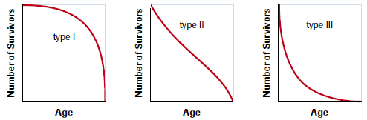
The genetic diversity of the sea otter population was greatly impacted and reduced as a result of the fur trade. The extirpation of the sea otter from the west coast meant that all of the genetic diversity within that population was wiped out. When a population of sea otters was re-introduced into the environment many decades later, the same genetic diversity did not exist, this is an example of the bottleneck effect (Carter-Edwards, 2011).
In a 2002 study, scientists were able to compare mitochondrial DNA between current sea otters, and those from the pre-fur trade era (Nichol, 2002). Specifically, they focussed on four microsatellite loci, and compared allele frequencies between the eras. Their results are shown in figure 4:
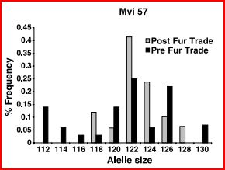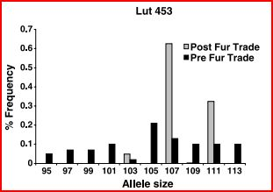
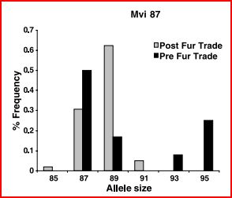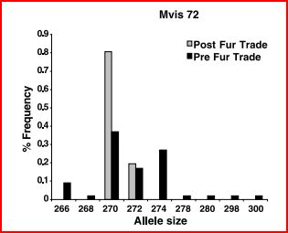
Overall, their study demonstrated that significant proportion of genetic diversity was lost as a result of the reduction in population size due to the fur trade. The total number of alleles across all loci were found and recorded for pre and post fur trade populations. The results showed that there was a total of 34 separate allele frequencies found in the pre-fur trade population, compared to only an average of 12.8 alleles found in the post fur trade individuals. In fact, there are only 16 observed alleles found amongst all current populations, which is significantly lower than the 34 alleles which were found in the one population of pre fur trade otters (Nichol, 2002).
The loss of genetic diversity was of particular concern when the 89 otters were re-introduced to the Canadian West Coast habitat. With a very small population size, there was a significant risk of loss of genetic diversity. However, the Otter population was able to overcome this obstacle, and now exists in large enough numbers that a loss of genetic diversity is of less concern (Fisheries and Oceans Canada, 2014).
Carrying Capacity and Minimum Viable Population Size
In a survey taken by the government of Canada in 2011, they estimated that the current population was around 3,180 sea otters. They also predicted that the carrying capacity of the population had not been reached, and that sea otters currently occupied only around 25%-33% of their historic range (Fisheries and Oceans Canada, 2011). From this estimation, one can extrapolate a rough estimate of the carrying capacity of the population. Using this information, a rough estimate of the carrying capacity of the British Columbian Coast is around 15,000 individuals.
When the population was extirpated and 89 sea otters were re-introduced in the late 1960’s, there was not initial success. The original population dropped to only about 28 individuals shortly after the population was introduced, however they recovered, and an aerial survey taken in 1977 counted 70 sea otters. The population was able to expand and prosper, and now without further intervention, the otters are back to a safe population. For these reasons, I believe that the minimum population would have to be around 25 individuals because the reintroduced sea otter population was able to survive and prosper when the population had dropped to less than thirty.

Population Characteristic Summary Chart
Population Characteristic | Current Situation | Future Projection
Dispersion | - Clumped dispersion pattern  - Does not occupy much of its original territory  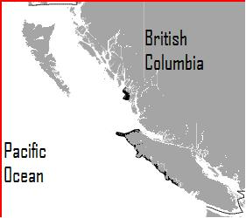 | - The otter population will expand into the territory the otter occupied before the extirpation in the late 1800’s  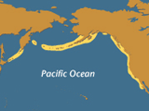
Density | - Varies; has reached carrying capacity in some habitats while others remained relatively remote | - The density will increase in areas that are uninhabited now, as the population expands and prospers
Age Structure | - Stable age structure, with a type two survivorship pattern | - This pattern will continue because of the relatively stable and expanding population
Genetic Diversity | - Very low because of the bottleneck effect, when 89 individuals were reintroduced to Canada  - Low compared to pre extirpation genetic diversity | - It will increase slightly as the population continues to grow, and mutations occur  - It will take hundreds of years to reach similar genetic diversity to that of the pre fur trade otters
Carrying Capacity and  Minimum Viable Population Size | - Carrying Capacity is around 15,000  - Minimum Viable Population is around 25-30 individuals | - N/A

Population Growth
Historical Data
Sea otters once ranged from Northern Japan to central Baja California, and had an estimated global population of between 150,000 and 300,000. However hunting which began the downfall of the sea otter in the Northern Pacific Ocean. Initially, it was only the Native Americans who hunted the sea otter, however when Europeans came to North America and began the maritime fur trade, this amplified the problem (Nichol, 2002).
By the mid 1800’s, the sea otter was considered to be on the brink of extinction. In 1911, the global sea otter population dropped as low as 2,000 individuals, and the International Fur Seal Treaty was signed by Japan, Russia, the United States and the United Kingdom (for Canada). It included an article which prohibited non-natives and anyone hunting for commercial purposes from hunting sea otters. However, this did not prevent the sea otter population from continuing to decline, and in 1929, the last verified sea otter in Canada was shot and killed (Nichol, 2002).
For many years, there were no sea otters in Canadian waters and most of the sea otters in the world were located in the Aleutian Islands, off of the coast of Alaska. However in 1969, Canada undertook a reintroduction program which relocated 89 sea otters from Alaska to the coastal waters of British Columbia. This relocation project was initially unsuccessful, as the population dropped to 28 individuals when the otters were first introduced. In the following years, the otter population began to grow and prosper. From 1977-1995, the population showed steady growth and averaged 19.1% growth over this time period (Nichol, 2002).
Although the sea otter was extirpated from the Canadian West Coast, it was reintroduced and once again become a part of the ecosystem, as shown in figure 1. Over recent years, the status of the sea otter was upgraded from endangered to threatened, and as of 2004, the otter was once again upgraded to a species of special concern. In the most recent study in 2008, the sea otter population in British Columbia had increased to about 4,700, up from 3,200 in 2004. In general, the current otter population is stable, however its troubled past and vulnerability to oil spills result in the need to protect the species (Fisheries and Oceans Canada, 2013).
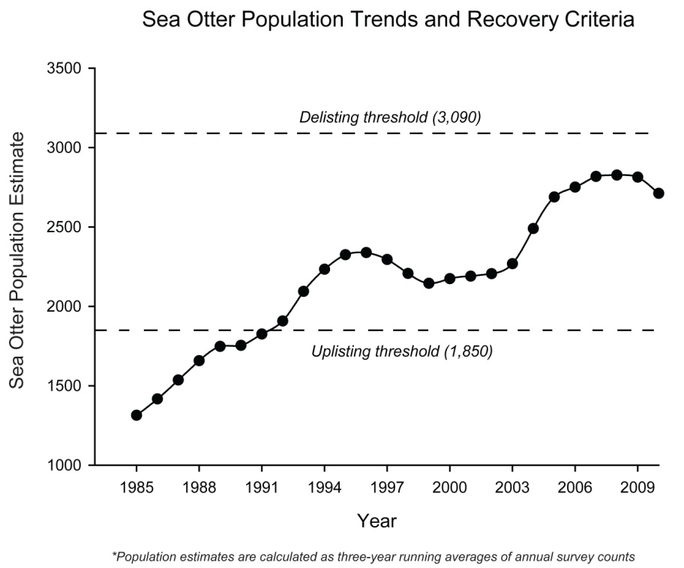
Sea otter population measured off the coast of Vancouver Island

Population Growth Pattern
In 1969, 89 otters were re-introduced to the British Columbian Coast Line (Province of British Columbia, 2003), which marked the beginning of a growth curve. In general, the growth pattern exhibited by the sea otter population is logistic growth (Carter-Edwards, 2011). Obviously in practise, there are many factors that contribute to population growth, and no population will directly follow the logarithmic curve. Despite this, there are still many similarities between the logistic growth curve, and the growth patterns of the British Columbian sea otters.
Firstly, when initially introduced to the new environment, the sea otters experienced repressed growth. On the logistic curve, this lack of growth (the lag phase) is attributed to the lack of individuals, and therefore the lesser ability to create a great number of offspring. In fact, when the sea otter population was initially introduced, it experienced negative growth. This was not only due to a small initial population size, but also a rapid change in environment for the relocated creatures (Province of British Columbia, 2003).
Next, the population began to increase rapidly, in a section of the log curve known as the log phase. In this phase, a rapid increase in population can be attributed to an adequate population size, and an abundance of resources. This too happened in the sea otter population, as they experienced an average rate of change of over 19% per year from 1977 to 2004. In this phase, the sea otter was reclaiming the territory it once occupied, and had adequate resources to do so.
Currently, according to the log curve, and given the carrying capacity of the sea otter population, they should still be in the log phase of the curve. However the actual rate of growth has slowed to around 8% each year from 1995 to 2004 (Environment Canada, 2014). Although this does not make sense in theory, as the current population of around 4,000 is far less than the carrying capacity (14,000), there is an explanation. As the population expanded, they mostly increased in numbers in their current habitat rather than expanding to reclaim lost territory. As a result, the areas currently occupied by the sea otter have reached equilibrium densities, and as a result the growth has diminished. For the population to continue expanding at a high rate, they must expand to other parts of the coastline, and continue to grow in numbers.
Five Year Population Projection
Based on the current population, and most recent growth pattern found, one can extrapolate the following growth over the next five years for sea otters off the coast of British Columbia:
$x\left(t\right)=a*b^{\frac{t}{r}}$ a = the initial population at t = 0
b = the rate of change each time unit
t = the total time of growth
r = length of time for one growth cycle
$$x\left(t\right)=\left(4700\right){\left(1.08\right)}^{\frac{5 years}{1 year}}$$
$$x\left(t\right)=6906$$
Therefore, based on current trends, the most recent population and the logarithmic growth equation, one can estimate the sea otter population will be about 6906 in five years. However there are sources of error within this estimation. For example, the population used in this calculation is taken from 2008, which means that any prediction made, starts in 2008. This means that the predicted population 5 years in the future is really only for 2 years in the future (2013). Also, the growth pattern used was based on observed populations from 1995 to 2005, which may have changed more recently. For these reasons, this is only an estimation, and should be used solely as a rough estimate of future populations in the British Columbia area.
Population Limiting Factors
The main limiting factor of the sea otter population is the result of interactions with other species, including humans. This includes predators, prey, and competition from other species, parasitic infection and changes in environment due to human interaction (Environment Canada, 2011). Human interaction includes such disturbances such as over hunting, oil spills and accidental death such as fishing nets which can trap and drown sea otters. These interactions will be discussed later, but include relationships with the great white shark, bald eagles, kelp, sea urchins, parasites and of course humans.
Other than special interactions, there are other factors that limit the sea otters population. For example the sea otter has a very low biotic potential. Because the sea otter only lives for around 10-20 years (Environment Canada, 2011), and is only able to produce one offspring every year, the population does not have the ability to grow quickly. To compound this problem, many of the pups who are born will not reach the age of sexual maturity for a variety of reasons including predation and habitat contamination.
Also, the sea otter population is relatively sedentary, meaning that they do not migrate and tend to live in the same general area for long periods of time. For this reason, it is more difficult for the sea otter population to expand to other geographical locations. This limits the population because rather than having the space to exponentially expand the population, they are confined to an area which will likely reach its carrying capacity, and stunt the population growth (Environment Canada, 2011).
Species interactions
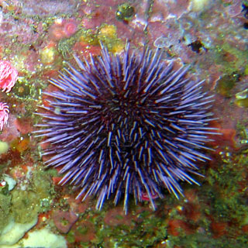
The sea otter interacts with a variety of animals around it for a variety of reasons. In fact, the sea otter is recognized as a keystone species in the rocky sub tidal habitats (Costa, 2011). This means that the sea otter has a greater impact on its community than would be assumed based on its population. Although no animals were responsible for the demise of the sea otter, they all can impact how prosperous the sea otter is in its current environment. A few of these animals are the sea urchin, the Toxoplasma gondii, kelp, the great white shark and the bald eagle (Costa, 2011).
The sea urchin is a class of echinoderms, who live on the rocky bottom of ocean floors. They can live in either cold or warm water, but must live in salt water environments. These small creatures will be captured by sea otters when they dive, and brought to the surface. In this predator-prey relationship, where the urchin is the prey and main source of food for the sea otter, sea urchins play a large role in the population growth for the otter (Costa, 2011). If there was a decrease in sea urchin population, this would consequently have an adverse effect on the sea otter. Although, the sea otter is a very versatile consumer, it is possible that this could harm the sea otter population. However if there was an abundance of sea urchins, this would be very beneficial because food would not limit the sea otter’s population. This would encourage an increase in sea otter population, and possible expansion into other areas of the coastline.

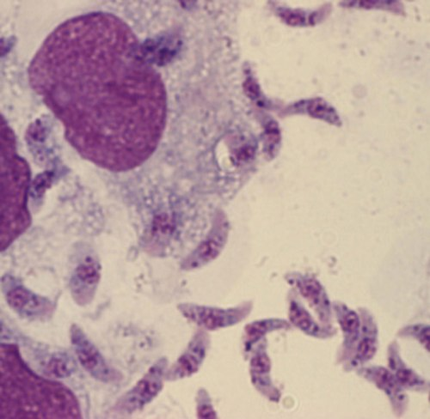
Another species that the otter interacts with is the parasite known as Toxoplasma gondii. These parasitic protozoans are a major cause of death within the sea otter community. In this parasitic relationship, the sea otter is harmed while the protozoan benefits (Costa, 2011). This relationship has a severely negative effect on the otter population. Although diseases and parasites are not generally a major cause of death for otters, this particular parasite is especially detrimental to southern coastal otter populations. For this reason, the sea otter population growth would be stunted by such a parasite, which has the ability to kill many individuals.
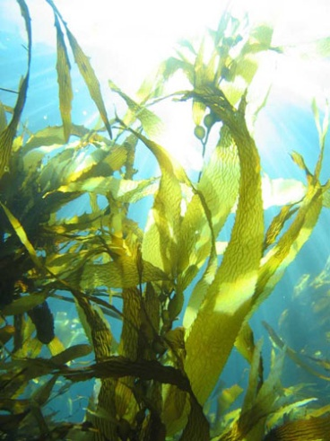
The sea otter also has an ongoing relationship with brown algae (aka kelp) which is mutualistic (Costa, 2011). In this relationship, the sea otter eats sea urchins, as discussed above. These urchins would usually eat the majority of the kelp; however the sea otters can prevent this. Sea otter benefit from this relationship because they use kelp to anchor themselves when they sleep. Although this relationship does not have a direct impact on the sea otter population growth patterns, it is beneficial.

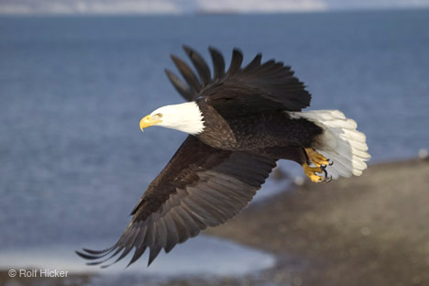
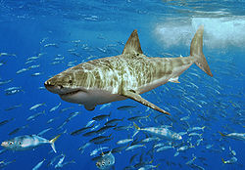
The great white shark is one of the most feared predators all over the world. This shark lives along coastlines and around the equator because of the warm water temperatures. The great white will prey on the sea otter as a source of food along the north eastern coast of the Pacific Ocean. In this predator-prey relationship, the sea otter is the prey, and its population is directly impacted by the shark (Costa, 2011). If there is a larger population of sharks in the area, the population of sea otter will be greatly affected. This could repress population growth in an area with many sharks within the territory.
Finally, the bald eagle is known to prey on sea otter pups. This is important because the pups are those who would be reproducing in the future. Because the bald eagles prey on the pups specifically (because of their size) this can change the age structure of the sea otter population. In this predator-prey relationship, the sea otter pups are the prey, and the bald eagle is the predator (Costa, 2011). This could have a detrimental effect on the sea otter population, because removing a large portion of the pups from the population would have adverse effects on the population many years into the f
Human Influence
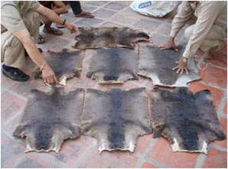
Of all the species to impact the sea otter, humans have likely done the most harm due to the species. For a variety of reasons in the past and present, humans have damaged the sea otter population. From hunting to oil spills to entanglement in fishing gear, there are a variety of ways in which the humans harm the sea otter population.
Firstly, commercial hunting is the most prevalent way in which the sea otter population was harmed by humans (Environment Canada, 2011). During the 17th and 18th centuries, the sea otter was hunted for its valuable pelt. Hunting was not regulated, and consequently the population quickly diminished. Although though the global community eventually took notice and banned the commercial hunting of sea otters in 1911 (Environment Canada, 2011), it was too late. About 20 years later, the last known sea otter in Canada was shot and killed. If it was not for this horrific exploitation of the sea otters, there would have been no need for a reintroduction plan, and the population size would be stable, and likely at carrying capacity.
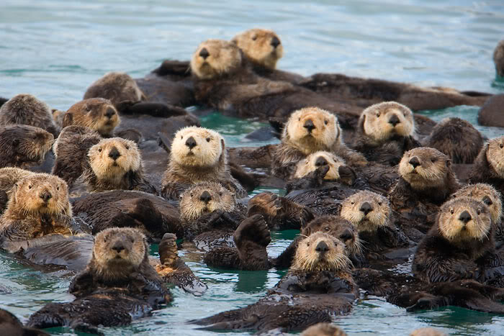
Now that the otter population is relatively small and vulnerable, oil spills have become of major concern to sea otter populations. The reason the otter is so greatly affected by oil spills is because of predisposed traits. Firstly, oil will destroy the water repellent nature of their fur, which will reduce insulation by up to 70%. Once the fur is fouled, the otter will groom itself continuously, causing them to ingest oil and cause internal organ damage (Environment Canada, 2011). As a result, the most prevalent cause of sea otter death in an oil spill is hypothermia. There are methods for cleaning the water and rehabilitating sea otters caught in oil spills, however the methods are costly and depend on finding the otters before they freeze (Environment Canada, 2011).
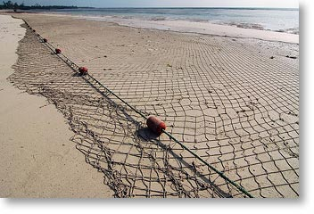
Another reason that sea otters are susceptible to oil spills is because they often travel in large same-sex rafts (Environment Canada, 2011). If one raft of 200 males were to be caught in an oil spill, this would greatly reduce the fertility of the sea otter population moving forward, and likely have significant population trauma many years into the future (Environment Canada, 2011). However this issue is not expected to stop, because it is predicted that major oil spills off the western coast on North America will occur every 1.3 years. Annually, it is expected that there will be at least 15 oil spills of the coast of Vancouver alone (Province of British Columbia, 2003). This issue presents a challenging problem for scientists who know that despite the danger, oil transportation must continue along the North American west coast.
Mortality due to entanglement in fishing gear and collisions with vessels is also high in sea otter populations. Specifically, incidental drowning in sunken gill nets was a significant cause of death in the late 1970’s (Environment Canada, 2011). To combat this problem, restrictions were introduced fishermen, which prevented the use of gill nets inside a water depth of 65 meters (which is outside the normal sea otter habitat) (Environment Canada, 2011). However, there are still frequent accidents involving sea otters drowning in fishing nets up and down the west coast. As the population continues to expand, this will be an ongoing issue which will need to be quickly dealt with to ensure the safety of the otter population.
Other issues such as environmental contaminants have affected the otter population in the past, such as the use of DDT, however these issues are not currently prevalent. It is encouraging to note however, that since illegal hunting has all but stopped, and the government is calculating exactly how to reduce human induced sea otter death. They have calculated that it is acceptable for there to be around 140 sea otter deaths each year due to human interactions (Environment Canada, 2011). Although this may sound high, it takes into account oil spills, and this prediction is a tool in devising plans to further limit human induced otter death.

Canadian Sea Otter Recovery Team (CSORT)
Conservation Biology
Recovery Plans Already in Place
There are a variety of initiatives already underway which try to improve the sea otter population, and limit human induced death. Since 1977, surveys of sea otter populations have been carried out, and recently, a standardized method of surveying was introduced so that population estimates are as accurate as possible. In addition, scientists have undertaken the project of examining the health of the sea otter population. By live capturing an individual, and preforming blood and genetic tests, they can identify the genetic origin and contaminant exposure (Fisheries and Oceans Canada, 2013).
The oil spill response was introduced in 1995; however it is not specific to sea otters, rather the treatment of oil spills in general. In response to this, the Canadian Sea Otter Recovery Team formed an oil response plan specifically for the sea otter, and implemented it in 2004 (Fisheries and Oceans Canada, 2013).
In 2010, the Government of Canada launched a recovery plan with the goal of reaching a population size where even a catastrophic event would not severely diminish or even extirpate the sea otter population. To see this happen, they have set out objectives for the recovery plan:
- To see the geographical range of the sea otter expand beyond the current range, so that a catastrophe such as an oil spill would only effect the population for a short period of time.
- To see the number of individuals to correspondingly increase as the geographic range increases.
- Identify and mitigate threats to sea otters and their habitats, aiding the recovery of the population.
To reach these goals, the government has described a few approaches which they plan to implement, which will benefit the otter population:
- They will continually research threat clarification, which will identify the most prevalent threats to the population at any given time.
- They will also continually assess the population including surveys and distribution charts, which will help them to accurately estimate the populations carrying capacity.
- The Government plans to protect the otters by immediately responding to oil spills according to the plan devised by the Sea Otter Recovery Team (SORT).
- Respond to issues as they arise such as an increase in death due to environmental contaminants.
To measure success, performance measures have been devised, and will be evaluated 5 years into the plan:
- Did the geographic population continually expand?
- Did the number of sea otters increase proportionally to the increase in geographic range?
- Were the threats identified and addressed in the most effective way possible to mitigate threats and provide continued recovery
My SORT (Sea Otter Recovery Plan)
To supplement the plan set aside by the Canadian Government, there are a few initiatives that I would like to see take place in order to better protect the sea otter population in the immediate future and long term.
I would firstly create more specific approaches to improving the sea otter population. Because I found the measures and approaches set out by the government very vague, I would propose that detailed plans be made and specific measures of success be outlined.
One of the approaches I would use would be to impose sanctions on fishing within coastal communities. By decreasing the amount of fishing nets being dragged through the coast line, there would be less sea otters caught and drowned in these nets. I would also monitor all current fisheries, and identify any areas where there are repeated instances of sea otter death due to fishing nets. The area could then be investigated, and the appropriate response can be taken to ensure the safety of the sea otter, but also the viability of the fishing business.
Secondly, I would impose further restrictions on the transport of oil along the coast line. Firstly, I would force all large ships carrying oil up or down the coast to travel miles away from shore rather than fairly close to the coast line. By protecting the coastal environments, thousands of species would benefit because the area has a more diverse population, and is delicate compared to the middle of the ocean.
If the sea otter population was not expanding and reclaiming its lost habitat, I would consider relocation again. This would ensure that there were small communities in all of the habitats that they once occupied, and would very quick growth due to an abundance of resources in these untapped environments.
Finally, I would encourage all countries involved in the original Fur Seal treaty in 1911 to collaborate on another treaty which would combine efforts of all the nations to protect these animals. By having all these countries sign the treaty, there would be consistent work being done all along the coastline to ensure that the sea otter population was rehabilitated to a stable population.
Careers in Conservation Biology
There are many career options that would allow one to study environments and animal at risk including biologists, ecologist and environmentalists.
A biologist in the field of environmental protection would work directly with animals and their habitats and would be primarily responsible for monitoring the effects that chemicals and other environmental pollutants have on animals and their habitats. The biologist and ecologist careers overlap, but generally the biologist would work with animals. An ecologist career related to protection of animals and their habitats would study the ecosystems and make recommendations for improvement and protection of ecosystems that are at risk. Working at CSORT would provide the opportunity to focus on environmental concerns related to the protection of animal species, for example the sea otter.
A career as an environmentalist's involves helping the public to make informed decisions about natural resources and interaction with our surroundings. Through research, publications and lobbying, environmentalists provide information on the environment. An environmentalist could focus on protection of species at risk working as an environmental scientists, environmental lobbyists or environmental educators. An environmental scientists study the best ways to preserve the environment and protect it from pollution and other contaminants. Environmental educators teach students environmental science and related subjects. Environmental lobbyists work for organizations to influence legislators on environmental issues and policy. There are several organizations in Canada that are dedicated to the protection of native animals in their natural habitat including, Friends of the Sea Otter, which focuses on the conservation of sea otters by educating the public, supporting research, and advocating for the protection of the sea otter, and the Humane Society, an animal protection organization focusing on the protection of all animals through advocacy, education and hands-on programs.

